*

CLDV6211

POE Part 2

Arlo (Abby) Staples

ST10404431

Table of Contents

PART ONE 3

ERD 3

Azure Server 3

SQL Server Azure Database 3

Table Results with SELECT * FROM Venues 3

Web Application Home Page 3

Create New Event 3

Theoretical 3

PART TWO 3

Theoretical 3

Home Pages 3

Venues Index 3

New Venue 3

Venue Details 3

Update Venue 3

Delete Venue 3

Search Venue 3

Events Index 3

Create Event 3

Update/Edit Event 3

Event Details 3

Delete Event 3

Booking Index 3

New Booking 3

|  |  |  |
| --- | --- | --- |
| LINKS | | |
| Azure | <https://evenease-gah5euanhbhxd3cg.southafricanorth-01.azurewebsites.net> |
| Video |  |
| GitHub | <https://github.com/StaplesArlo/CloudDevPOE.git> |

PART ONE

ERD

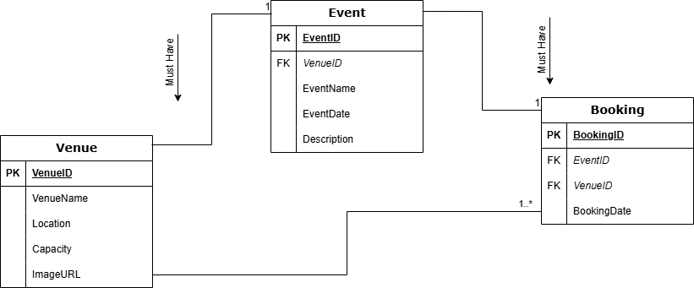

Azure Server

SQL Server Azure Database

Table Results with SELECT * FROM Venues

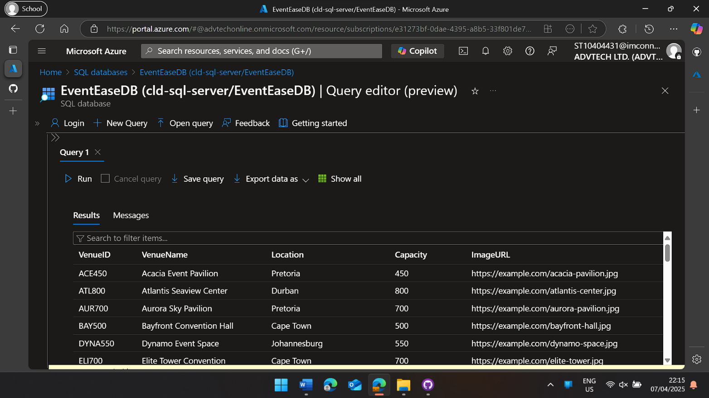

Web Application Home Page

Create New Event

Theoretical

Cloud Hosting Models:

Cloud hosting models define how data is stored and managed online:

* **Public Cloud**: Shared resources, cost-effective, scalable.
* **Private Cloud**: Dedicated, secure, more expensive.
* **Hybrid Cloud**: Mix of public and private for flexibility.
* **Multi-Cloud**: Uses multiple providers to avoid reliance on one.
* **Community Cloud**: Shared by groups with common needs, like healthcare or government.

On-premises vs. cloud deployment

On-premises vs. cloud deployment is about where a company’s IT infrastructure lives:

* **On-Premises**: Servers are physically owned and managed by the company. This offers complete control but requires high costs and maintenance.
* **Cloud Deployment**: Servers are hosted by providers like AWS or Azure, and businesses access them remotely. It’s more flexible and cost-effective but has some limitations on control.

PART TWO

Theoretical

1. Azure Cognitive Search is an AI-powered cloud search service that improves traditional search engines by using natural language processing, semantic ranking, and cognitive skills like OCR and sentiment analysis. Unlike basic keyword search, it indexes structured and unstructured data, scales automatically, and offers built-in security features.
2. Normalization in cloud-based design helps organize data efficiently by reducing duplication and ensuring consistency. It improves storage, speeds up queries, and makes databases easier to scale. By structuring data properly, applications run smoother and remain reliable in the cloud.
3. Relational databases use structured tables with a fixed schema, making them great for storing organized data with strict rules. NoSQL databases are flexible, handling unstructured or semi-structured data, and they scale easily across multiple servers. SQL databases work best for transactions, while NoSQL is ideal for big, fast-changing data like social media.
4. Durable Functions help cloud apps run better by managing long-running tasks without wasting resources. They allow automatic scaling, reliable execution with retries, and faster processing by running tasks in parallel. This makes apps more efficient and cost-effective in the cloud.

Home Pages

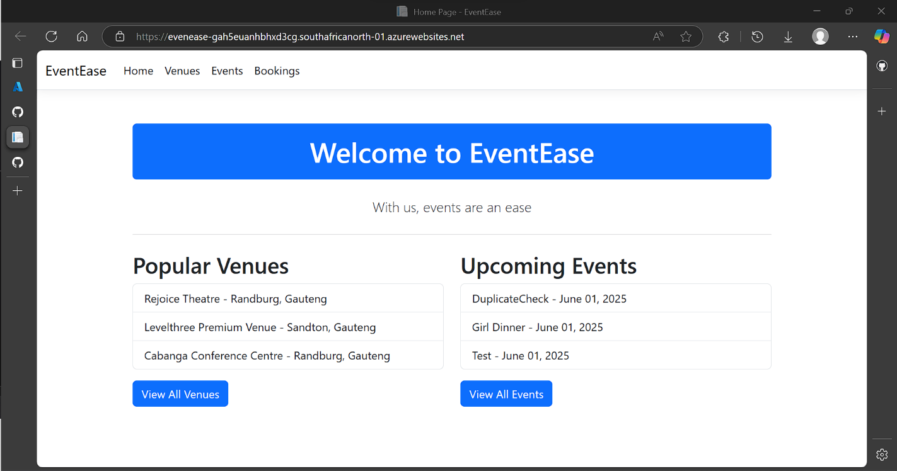

Venues Index

New Venue

Venue Details

Update Venue

Delete Venue

Search Venue

Events Index

Create Event

Update/Edit Event

Event Details

Delete Event

Booking Index

New Booking

